Report for: | Planning Policy Advisory Panel
Date of Meeting: | 21 March 2024
Subject: | Assessment of possible Local Areas of Special Character (LASC) – first tranche
Key Decision: | Yes – when considered by Cabinet (impacts upon two wards)
Responsible Officer: | Viv Evans, Chief Planning Officer
Portfolio Holder: | Councillor Marilyn Ashton, Deputy Leader of the Council, Planning & Regeneration Portfolio Holder
Exempt: | No
Decision subject to Call-in: | No
Wards affected: | West Harrow and Pinner South
Enclosures: | Appendices:  1 – Areas considered  2A – Site photos of Butler Avenue  2B – Site photos of Lance Road  2C - West Harrow Recreation Ground  3 – Butler Avenue and Lance Road Historic Photographs  4 – Butler Avenue and Land Road Ordinance Survey (OS) Map regression  5A – site photos of West End Avenue Edwardian part  5B – Meadow Road Edwardian part photo survey  5C – Eastcote Lane photos  6 – Historic photographs of West End Avenue  7 – Ordinance Survey (OS) Map regression

Section 1 – Summary and Recommendations
This report presents an assessment of two areas for potential designation as Local Areas of Special Character (LASC) and recommends that these areas are commended to Cabinet for approval to undertake consultation on the proposed areas and accompanying assessments. The assessments have been undertaken against the criteria commended to Cabinet at the Panel’s meeting in July 2023 and subsequently agreed by Cabinet on 14th September 2023.

Recommendations:

The Planning Policy Advisory Panel is requested to:
(A) consider and comment on the results of the review of two areas shown in Appendix 1 as proposed ‘Local Areas of Special Character’ (LASCs) namely 3-29 (odd) and 2-40 (even) Butler Avenue and 2-26 (even), 1-33 (odd) Lance Road and West Harrow Recreation Ground, and in Pinner 1 and 3 - 40 (all) West End Avenue, 1-40 (all) Meadow Road and 24-38 (even) Eastcote Lane.
(B) Commend the two recommended areas for designation as Local Areas of Special Character to Cabinet for approval to undertake consultation, with the outcomes of the consultation to be reported back to the Panel and Cabinet.

Reason:
Harrow benefits from an exceptionally diverse historic environment. It includes Conservation Areas designated under the Planning (Listed Buildings and Conservation Areas) Act 1990 as ‘areas of special architectural or historic interest, the character or appearance of which it is desirable to preserve or enhance’. The National Planning Policy Framework [NPPF] cautions that ‘the concept of conservation not [be] devalued through the designation of areas that lack special interest’. At the same time the NPPF and Historic England’s national guidance recognise the importance and necessity of identifying and maintaining up to date records of the significance of local heritage assets. There are many local areas in Harrow that might not meet the strict criteria for Conservation Area status but do have local heritage interest. This is a parallel to the existing local designations of locally listed buildings and locally listed parks and gardens in Harrow for those buildings and parks that do not meet the strict criteria for national heritage designation. Accordingly, this report considers two areas against the designation criteria for Local Areas of Special Character and recommends specific streets / properties within these for consultation as Local Areas of Special Character. The local consultation undertaken would be in accordance with national best practice and the Council’s Statement of Community Involvement.

Section 2 – Report

1.0 Introduction

1.1 The report incorporates the corporate priority concerning:
- Putting Residents First

It also reflects the overarching objective of Restoring Pride in Harrow.

1.2 This report presents an assessment of two areas for potential designation as Local Areas of Special Character (LASC) and recommends that these areas are commended to Cabinet for approval to undertake consultation on the proposed areas and accompanying assessments. The assessments have been undertaken against the criteria commended to Cabinet at the Panel’s meeting in July 2023 and subsequently agreed by Cabinet on 14th September 2023.

1.3 Should the new areas proposed for the consultation ultimately be confirmed as Local Areas of Special Character, this will provide improved protection to help maintain the unique historical local character of areas or neighbourhoods within Harrow which residents cherish and value.

2.0 Options considered

2.1 The option of not considering areas as potential LASCs, nor subjecting two that are considered to meet the criteria for designation to local consultation, was considered but this would be contrary to the obligations placed on the Council under the NPPF (2023) which states in paragraph 198 that ‘Local planning authorities should maintain or have access to a historic environment record. This should contain up-to-date evidence about the historic environment in their area and be used to: a) assess the significance of heritage assets and the contribution they make to their environment’. It would also be at odds with the approach Harrow takes to buildings and landscapes of local interest, but not worthy of national interest via national versus local listing; this approach is reflected in Cabinet’s decision in September 2023 to agree criteria for locally designated Local Areas of Special Character.

2.2 The option of not consulting on the proposed LASCs was dismissed as such a process is considered beneficial with respect to testing the merits of the proposed areas in relation to the criteria for designation and the information used in this assessment.

3.0 Background

What is a Local Area of Special Character?

3.1 A Local Area of Special Character is a local form of heritage area designation based on the architectural and/ or historic interest of an area and complements the national statutory designation of conservation areas, where there is ‘special’ architectural and / or historic interest (a higher threshold for designation). It is a similar concept to Harrow’s ‘Local List’ of buildings, compared to its statutory listed buildings which are designated at a national level.

3.2 The Panel at its meeting on 22nd July 2023, agreed to this new local heritage designation of Local Areas of Special Character, to be seen as a lower level of heritage interest to those of statutory Conservation Area status. The new heritage designation is designed for areas with a level of local interest / significance that would benefit from formal recognition to assist in assessing development proposals within the area. The implication of the designation is that it where used it will be a material consideration for any planning applications in terms of whether what is significant about the heritage interest of that area is preserved by the proposal, either via a direct impact on it or via impact on its setting. Relevant heritage policies relating to non-designated heritage assets in the NPPF and Local Plan will apply i.e. the Core Strategy policy CS1: Overarching Policy and Development Management policy DM7: Heritage Assets. NPPF (2023) paragraph 209 applies which states:

‘The effect of an application on the significance of a non-designated heritage asset should be taken into account in determining the application. In weighing applications that directly or indirectly affect non-designated heritage assets, a balanced judgement will be required having regard to the scale of any harm or loss and the significance of the heritage asset’.

3.3 The emerging New Harrow Local Plan seeks to formally incorporate the concept of Local Areas of Special Character into the Council’s statutory development plan.

Criteria for designation

3.4 At its July 2023 meeting, the Panel commended the adoption of criteria for the designation of Local Areas of Special Character to Cabinet following earlier public consultation, and these were subsequently agreed by Cabinet at its 14th September 2023 meeting. The criteria connect back to national heritage policy and guidance on the heritage significance of heritage assets. It forms the basis of the consideration of any areas for potential designation:

- The area must be of heritage significance (as defined in the National Planning Policy Framework (2021) or any subsequent replacement).
- One or more of the following criteria need to be met:
a. Townscape of locally cohesive, well-preserved quality.
b. Architecture of locally cohesive, well-preserved quality.
c. Landscape of locally distinctive and well-preserved quality.

Overall, an area must have discernibly higher quality and degree of intactness than other parts of the borough (other than designated conservation areas, that have special architectural or historic interest), thereby demonstrating distinctiveness.

3.5 In December 2023, the NPPF was updated. The definition of ‘heritage significance’ did not change within it so the above is unaffected.

What areas to consider for designation?

3.6 During the public consultation undertaken March to April 2023 regarding the proposed criteria for the designation of Local Areas of Special Character, a number of areas were suggested by respondents for consideration. Two of these areas are considered in this report for designation.

3.7 Since then others have been suggested for consideration. Where there is a high concentration of locally listed buildings, further areas have also been identified as potential LASCs for review. Areas will be considered in due course.

- Butler Avenue, Lance Road and West Harrow Recreation Ground

4.1 The area considered is shown in Appendix 1. A site visit and photo survey (Appendix 2) has been undertaken of the area and immediate surrounds, along with local history research and discussions with the West Harrow Forum.

4.2 Local History research produced findings similar to those found previously when researching a wider area for Conservation Area status for the PPAP report of 30th November 2022. This has been supplemented by additional information and informal consultation with the West Harrow Forum in January 2024. Information identified through this research comprises:

- The streets began being developed from 1898 and were substantially completed by 1911 as shown by historic photos in Appendix 3 and historic OS map regression in Appendix 4.
- Early on the wider area came to be known as the Bessborough Estate, West Harrow. It was developed from three farms that existed along the Bessborough Road: Honeybun (owned by the Atkins family), Roxborough and Roxeth farms. Roxeth farm house still stands (outside of this study area) but all the farm lands were developed as the Metropolitan railway extended out from Baker Street. The original field patterns is evident in some of the remaining street layouts.
- The streets are named after Harrow School’s former headmasters and masters. Butler Avenue was founded 1898.
- John Betjeman filmed part of his seminal documentary ‘Metroland’ 1973 (approximately 18 minutes in) whilst standing nearby where he states:
‘Here at the foot of Harrow Hill, alongside the Metropolitan electric trains, tradesmen from Harrow built in the ‘80s or ‘90s I should think, from the look of the buildings, these houses, and a nice little speculation they were, quiet, near the railway station, and with their own church and public house, and they’re named, reverently, after the great people of Harrow School.’
- West Harrow Recreation Ground was added in 1923, over a decade after the development of surrounding houses. Some original features remain e.g. bowling green, half the tennis courts originally there, the central avenue of trees and other trees and footpaths around and beyond the former putting green. It has developed over time to remove the original putting green, park shelter and toilets, and include a basketball court, children’s play area, adventure play area, café and wildflower area.

Does Butler Avenue, Lance Road and West Harrow Recreation Ground meet the criteria for Local Area of Special Character status?

4.3 The additional information does not reveal any significant new findings since part of the area was assessed for Conservation Area status under Cabinet report of November 2022 and therefore this assessment is not repeated.

4.4 Both roads and the park are assessed as follows in relation to each of the LASC criterion listed in paragraph 3.4 above:

- The area must be of heritage significance (as defined in the National Planning Policy Framework (2023) or any subsequent replacement).

4.5 There is some level of heritage significance within the area primarily for the road names being named after Harrow School’s headmasters.

4.6 It is noteworthy that John Benjeman filmed part of his seminal documentary ‘Metroland’ 1973 (approximately 18 minutes in) nearby where he refers to the houses that include those in Lance Road and Butler Avenue as ‘a nice little speculation’ built at the foot of Harrow Hill, alongside the Metropolitan electric trains.

4.7 The park is from the 1920s and has some of its original features which provides a level of heritage interest.

- One or more of the following criteria need to be met:
A. Townscape of locally cohesive, well-preserved quality.

4.8 This criterion is met for Lance Road and Butler Avenue.

4.9 Most of Butler Avenue stands out positively from its surroundings as a relatively cohesive and well-preserved collection of Victorian houses/maisonettes and Edwardian houses. This is shown by the photograph survey covering Butler Avenue in Appendix 2A 3-29 (odd) and 2-40 (even) as they comprise a high concentration of high quality, distinctive and relatively intact Victorian detached houses/maisonettes (3-29 and 2-22) and Edwardian terraced houses (24-36), and 3 slightly later terraced houses (36-40) built to match that Edwardian group. The buildings therefore comprise just two distinctive and high-quality types of design.

4.10 First, the two storey Victorian detached house/maisonette (image 1 below). This includes pleasant decorative gauged soft red/orange brick arches and headers to windows. The frontage contains a single gable end which includes stepped levels of moulded brickwork within, with dentil courses which extend across the whole frontage just below the eaves line. There is a two storey bay adjacent the front porch, topped with a pitched clay tiled roof. The original porch is open and of two types, one sloping and one incorporating a mini-gable end, but both including decorative carved timber detail and clay tiles. Where it is a maisonette, the second front door is plainer, narrower and there is no porch. A fair number of original delicate timber sash multi-paned windows remain and multi-panelled front doors on selected buildings remain with ‘apron’ detail around letter box. Similarly, a fair number have their original clay roof tiling with decorative clay ridge tiles and front garden vegetation and a front wall.

4.11 However, a fair number of houses within this group have been rendered or pebbledashed over, replacement plastic windows/ front doors, and or replacement concrete roof tiles with decorative ridge tiles, and front boundary walls removed and hardstanding installed all over the front garden, which given the extent of changes means Conservation Area status is not reached. Similarly, on occasion the maisonettes have been converted to a house with the second front door removed and altered. The extent of alteration means a patchwork effect is there but limited enough to allow a noticeable local distinctiveness and cohesion.

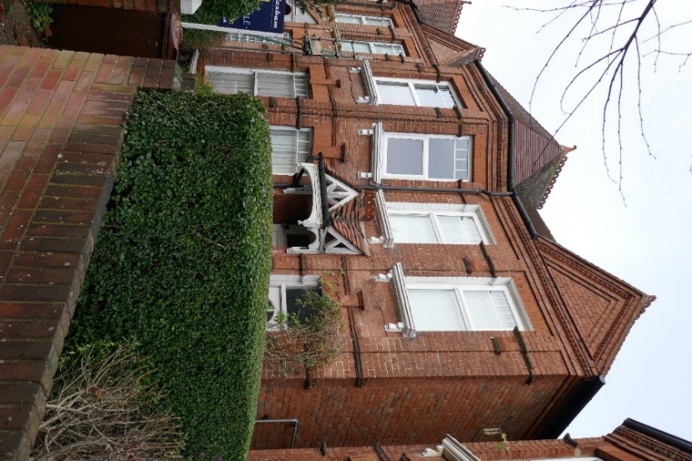
Image 1: Grand Victorian maisonette, Butler Avenue

4.12 Second, as shown by image 2 below there is the decorative terraced Edwardian house (or built just after the Edwardian period to match). These take from their earlier Victorian neighbours by having a similar form including a two-storey bay and front gable end, but differ by using distinctive applied black timber and white render detail, and more distinctly double fronted character. They have timber casement windows although a number have been replaced with plastic. The Edwardian ones have clay hanging tiles in their gable end, whilst the later infill have applied black timber and white render in the gable ends. The front door is a distinctive Edwardian style with oval glazing in the centre and timber panelling below. Unfortunately, many have replacement concrete tiled roofs, modern porches/front doors bringing the local cohesion down slightly.

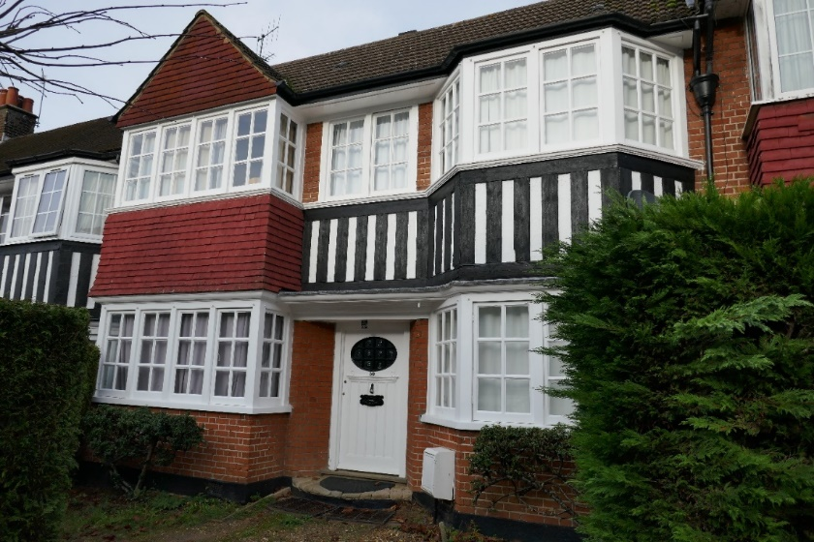
Image 2: Grand Edwardian house, Butler Avenue

4.13 The photo survey in Appendix 2B shows Lance Road 2-26 (even) and 1-33 (odd) has a cohesive and distinctive townscape and architecture given it comprises regular layout of terraced Victorian two storey brick cottages/houses. The cottages are red brick and feature have ground floor bay window and pitched sloping ground floor porch roof that also often covers the bay window also. The houses are similar but feature brown brick with red brick detail, a gable end with black timber and white render detail and two storey bay window. There are a number of decorative timber carved porch details, front doors and some remaining timber sash windows. The bay windows feature decorative pilasters. This is shown by images 3 and 4 below.

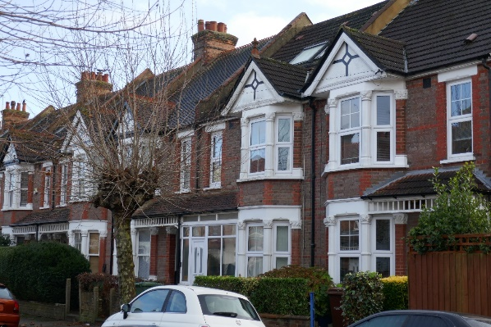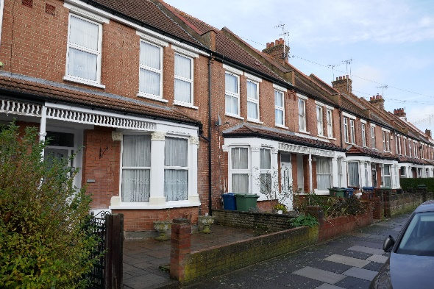
Images 3 & 4: Typical brick terraced house (left) and cottage (right) in Lance Road

4.14 This criterion is not met by West Harrow Recreation Ground given its nature as a principally landscaped space.

B. Architecture of locally cohesive, well-preserved quality.

4.15 This criterion is met for Lance Road and Butler Avenue as set out above.

4.16 This criterion is not met by West Harrow Recreation Ground given its nature as a principally landscaped space.

C. Landscape of locally distinctive and well-preserved quality.

4.17 Whilst the street layout of Lance Road and Butler Avenue reflects the subdivision of field land, this is usual throughout the development of much of Harrow since this reflects the pattern of land released for development.

4.18 The landscape is otherwise that of a typical residential street and there is either no landscaping at all or simply typical tree lining to the street or small front garden soft landscaping.

4.19 This criterion is not therefore met for Lance Road or Butler Avenue.

4.20 This criterion is met marginally for West Harrow Recreation Ground given it was built in the 1920s as a pleasant public green space which retains some of its pleasing original design namely: central avenue of trees, bowling green, and trees and footpaths.

Overall, an area must have discernibly higher quality and degree of intactness than other parts of the borough (other than designated conservation areas, that have special architectural or historic interest), thereby demonstrating distinctiveness.

4.21 As noted, these parts of Butler Avenue and Lance Road meet this criterion.

4.22 West Harrow Recreation Ground retains some of its original 1920s layout marking it out somewhat versus some other public green spaces in Harrow. This criterion is met marginally.

Areas surrounding Butler Avenue and Lance Road

4.23 The surrounding roads are generally pleasant largely early 20th century houses of similar scale in tightly drawn plots with some similarity in gable ends, chimneys and architectural details. They are highly altered, creating a patchwork character and are not discernibly different to other parts of Harrow of equivalent age. Whilst their street layout reflects the subdivision of field land, this is usual throughout much of Harrow.

4.24 Accordingly, these areas do not meet the criteria for Local Areas of Special Character.

Conclusion and recommendation

4.25 Based on the site and photographic survey, local history search and consideration of the criteria for designating a LASC, it is concluded that numbers 3-29 (odd) and 2-40 (even) Butler Avenue and 2-26 (even) and 1-33 (odd) Lance Road and West Harrow Recreation Ground should be recommended for consultation as a LASC as:

(a) There is a relatively strong locally cohesive, well-preserved quality to the townscape and architecture given the high concentration of consistently good quality decorative Victorian architecture. In Butler Avenue this comprises red brick detached houses/maisonettes of a single type and Edwardian terraced houses of a single type including a two storey bay window. These feature relatively consistent and good quality decorative features such as delicate timber windows, front doors, gauged brickwork detail, open porches with carved timber work and applied black timber and white render detail and moulded and gauged brickwork. In Lance Road this is terraced red brick two storey cottages with some original timber sash windows, and consistent porch and bay window details. The extent of alterations is too high and consistent for conservation area status but there is nevertheless a local distinctiveness and cohesion to an original quality and distinction of design that ensures the street stands out from surrounding ones.

(b) This area has additional historic merit given the association with the Harrow School masters who the streets are named after.

(c) West Harrow Recreation Ground retains some of its original 1920s layout and features marking it out to an extent versus some other public green spaces in Harrow.

5.0 Eastern half of West End Avenue and Meadow Road, and 24-38 (even) Eastcote Lane

5.1 The area considered is shown in Appendix 1 and the photo survey is Appendix 5. The areas were suggested by the Pinner representative of the Conservation Area Advisory Committee.

5.2 Local History research has determined the following in relation to the area’s history with particular reference to the historic photograph in Appendix 6 and historic OS maps in Appendix 7:

- The land begins in the late 1800s as fields and land associated with Pinner Place which was a farm standing where Ashridge Gardens is now.
- The Metropolitan Railway and Pinner Station arrive in 1885 and are shown on the 1896 OS map. The railway line drew the attention of those living in London to the area and speculative building began to appear near the centre. The development was intended mostly for the middle-class market.
- West End Avenue and Meadow Road and 24-38 (even) Eastcote Lane represent such development. They are laid out as streets of the length and size the remain today from 1907 to 1911.
- Edwardian houses were built from 1907-1911 and up to 1914 on the eastern parts of these roads with noticeable gaps where numbers 26 and 26A and 27A now are on West End Avenue. These houses all remain today i.e. numbers 1-39 (odd) and 4-40 (even) West End Avenue and 1-38 Meadow Road and 24-38 (even) Eastcote Lane.

Does the eastern half of West End Avenue, Meadow Road and 24-38 Eastcote Road meet the criteria for Local Area of Special Character status?

5.3 The area is assessed as follows in relation to each of the LASC criterion listed above:

- The area must be of heritage significance (as defined in the National Planning Policy Framework (2023) or any subsequent replacement).

5.4 There is heritage significance to the eastern half of West End Avenue and Meadow Road and 24-38 (even) Eastcote Lane as, notwithstanding some infill along West End Avenue, the area comprises streets laid out in Edwardian era built to accommodate speculative housing development for high quality Edwardian to early 20th century semi-detached houses. These were built along the eastern half of these roads to accommodate the middle classes seeking to move out of London but still have ease of access to it with the newly introduced Metropolitan railway station. It is reflective of a wider pattern with the emerging railways at this time.

5.5 This criterion is therefore met.

- One or more of the following criteria need to be met:
A. Townscape of locally cohesive, well-preserved quality.

5.6 This is found along the short stretches of numbers 1-39 (odd) and 4-40 (even) West End Avenue and 1-38 Meadow Road and 24-28 Eastcote Road (see the photo survey in Appendix 5). The houses comprise a high quality and distinctive collection of similar semi-detached Edwardian and slightly later pre-World War one houses. The width of the road is wide in both groupings, emphasising the presence that the buildings have.

5.7 Along West End Avenue 1-39 (odd) and 4-40 (even), the houses are symmetrical semi-detached pairs of a single core form comprising two storeys, hipped roof, projecting front two storey bay with recessed remainder. Each has a central chimney, and a bookend chimney on each side elevation. Two examples are shown by images 5 and 6 below. There are a handful of different decorative variations on this design. The modern infill development of numbers 26 and 26A and 27A West End Avenue undermines cohesion slightly.

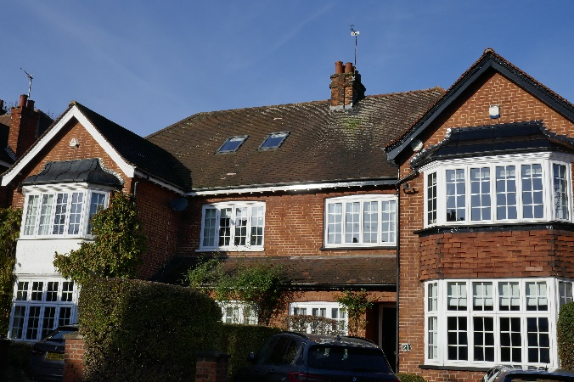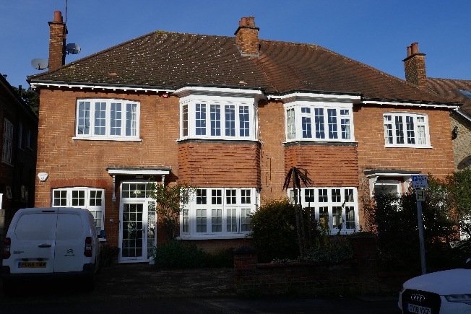
Images 5 and 6 – Semi-detached pairs of Edwardian houses, West End Avenue

5.8 The core form comprises Flemish bond red brick with clay hipped tiled roofs. Often there are bracketed eaves. On occasion there is brick banding detail on the front and side elevations and gauged brickwork above windows/doors. Some of the bays are topped with a gable end facing the road whilst others have a roof or decorative curved leaded roof above this. The bay features rectangular timber bay window with (often) clay tile hanging between ground and first floors although sometimes this is rendered. The gable end is either red brick with timber bargeboard or red clay tile hanging. The porches are of a few decorative and high-quality designs. This is either:

- a sloping clay tile roof leaning against the front wall and running across each half of the semi-detached pair joining each other between the two bays producing a single storey front addition; or
- two triangular hipped roofs topped with and joined by bonnet tiles and propped up by simply delicately carved timber posts and set away from and opposite each other between the projecting bays.
- Simple flat wooden hood with simply carved decorative wooden brackets
- recessed open brick front porch

5.9 Some of the original timber panelled doors with glazed oval window (sometimes stained glass) remain, as do a fair number of the original timber casement windows. A fair number retain front garden greenery and a low brick wall formally marking the boundary.

5.10 The houses are gently staggered in line with the slope of the hill creating a pleasing rhythm to their appearance in combination with the regular roof design and bay frontages.

5.11 Along 1-38 Meadow Road and 24-38 Eastcote Road the houses are similar semi-detached pairs but of slightly simpler and more uniform character. These are of a single core form shown in image 7 below as a symmetrical two storey pair with (most having a two storey bay, but the remainder with single storey bay), hipped pitched roof with every house having a gable end facing the road. There is more use of render in the mix of external finishes but plenty of Flemish bond red brickwork also. Roofs are of clay with bonnet tiles. There is some clay tile hanging and applied black timber and white render and again some brick banding. All semi-detached pairs featuring a hipped pitches roof though some include a gablet to add some variety. All porches are of a simple flat wooden hood with neat small bay window adjacent. There are rectangular casement timber windows and many of the original timber panelled doors with glazing within remain. There is some decorative stained glass again.
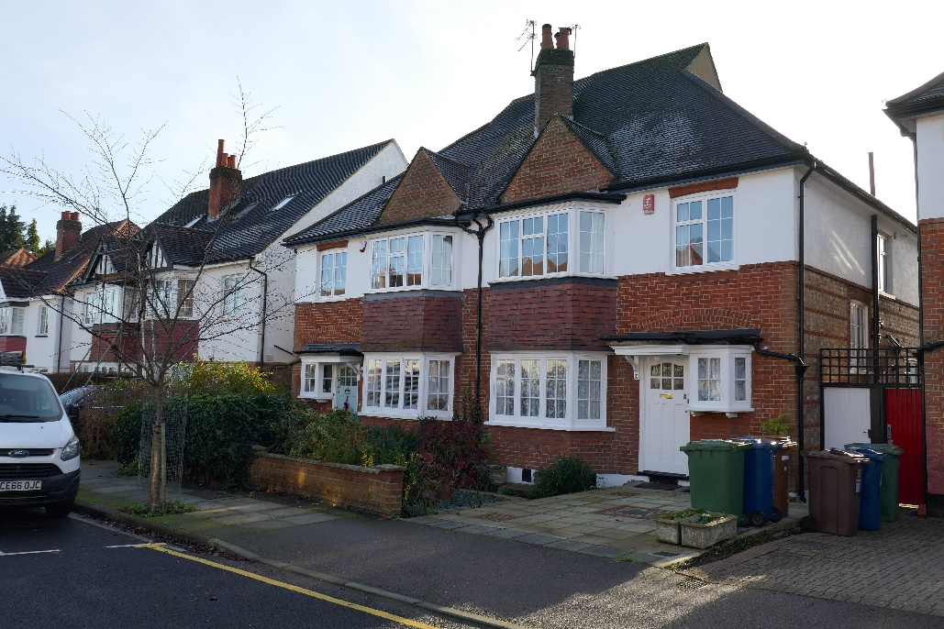
Image 7: Semi-detached pair of Edwardian houses along Meadow Road

5.12 There is though loss of front boundary treatments, extensions (including roof extensions such as hip to gable additions) offsetting symmetry, loss of original porches, front garden hardstanding, replacement plastic windows and rooflights and rendering over whole frontages. All together these elements undermine quality and cohesion to the extent that any possible conservation area status would not be appropriate.

5.13 This criterion is therefore met at numbers 1-39 (odd) and 4-40 (even) West End Avenue and 1-38 Meadow Road and 24-28 Eastcote Road.

B. Architecture of locally cohesive, well-preserved quality.

5.14 This criterion is met as set out above.

C. Landscape of locally distinctive and well-preserved quality.

5.15 The wide street to Meadow Road and West End Avenue provides some distinction, with wide granite kerbs to West End Avenue also standing out somewhat. However, there is little in the way of landscape that is otherwise locally distinctive and so this criterion is not clearly met.

Overall, an area must have discernibly higher quality and degree of intactness than other parts of the borough (other than designated conservation areas, that have special architectural or historic interest), thereby demonstrating distinctiveness.

5.16 The Edwardian and pre-World War I houses along 1-38 Meadow Road and 24-38 Eastcote Road and 1-39 (odd) and 4-40 (even) West End Avenue have a locally cohesive and well-preserved townscape and architectural quality. Notwithstanding incremental alterations, this stands out discernibly from surrounding streets which also formed part of this study area, and wider Harrow. The historic interest relates to the age of this development and its association with the spread of the Metropolitan Railway to Pinner. This criterion is therefore met for 1-38 Meadow Road and 24-38 Eastcote Road and 1-39 (odd) and 4-40 (even) West End Avenue.

Conclusion and recommendation

5.17 The Edwardian and pre-World War I houses along 1-38 Meadow Road and 24-38 Eastcote Road and 1-39 (odd) and 4-40 (even) West End Avenue have a locally cohesive and well-preserved townscape and architectural quality, that is not found in surrounding roads. It has historic interest as early (pre-1914) speculative housing built following the arrival of Pinner Station. It is recommended that the area is recommended for consultation as a LASC.

6.0 Next Steps

6.1 The assessments above and recommended areas will be reported to Cabinet for approval to consult. If agreed by Cabinet, the Conservation Team will commence consultation regarding the proposed designation of two areas of Local Areas of Special Character. This will comprise six weeks of consultation with local residents within and conservation groups relating to the proposed areas. Local residents (within the proposed areas only) and conservation groups will each be sent a letter/email and two site notices will be put up within each area. The letter of consultation will include the criteria for designation, explain why the area is considered worthy and invite comments on the matter providing six weeks for a response. A short online survey will be included in the MyHarrow Talk engagement platform to assist in receiving feedback from residents and local groups.

6.2 The outcomes of the consultation will be reported back to the Panel mid-2024.

7.0 Performance Issues

7.1 The new designation will assist in protection of Harrow’s local heritage.

8.0 Procurement Implications

8.1 There are no procurement implications in the new local heritage designation.

9.0 Environmental Implications

9.1 The designation would not have a direct environmental implication since it would be a heritage designation. But it may result in the preservation of landscape of locally distinctive and well-preserved quality which may have a positive environmental implication.

Ward Councillors’ comments – These will be sought from relevant ward members as part of the formal consultation process.

Risk Management Implications

Risk included on Directorate risk register? No

Separate risk register in place? No

Risks included on corporate or directorate risk register? No

Separate risk register in place? No

The relevant risks contained in the register are attached/summarised below. n/a

The following key risks should be taken into account when agreeing the recommendations in this report:
Risk Description | Mitigations | RAG Status
Consultation not undertaken in accordance with statutory requirements | - There are no statutory consultation requirements as LASCs are a local designation.  - Appropriate requirements will be reviewed (i.e. Harrow’s Statement of Community Involvement) and followed where relevant. | GREEN
The agreement of the criteria for Local Areas of Special Character is later challenged | - The criteria connect back to national heritage policy and guidance on the heritage significance of heritage assets including the NPPF and Historic England the guidance document entitled Local Heritage Listing Historic England Advice Note 7 which provides a list of various criteria likely to indicate the nature of heritage significance/interest.  - Consultation was undertaken and responses informed the final criteria. | GREEN
The assessment of the two areas and recommendations are challenged | - A similar process to the well established process of identifying and assessing areas for potential conservation status has been followed, except the criteria for LASCs have been applied.  - The consultation process is intended to seek comment and feedback on the information used in the assessment, as well as the assessment itself. This will assist in improving the robustness of any final conclusions and recommendations. | GREEN

Legal Implications

The Council has a statutory duty and is required under section 69(2) of the Planning (Listed Buildings and Conservation Areas) Act 1990 to carry out reviews ‘from time to time’ to determine whether any parts or further parts of their area should be designated as conservation areas; and if it so determines, that part(s) shall be so designated. It follows that those not worthy, but still of heritage value, are recognised in accordance with the NPPF paragraph 192’s requirement that: ‘Local planning authorities should maintain or have access to a historic environment record. This should contain up-to-date evidence about the historic environment in their area and be used to: a) assess the significance of heritage assets and the contribution they make to their environment’. The assessment and recommendations in relation to the two areas considered aid in meeting the Council’s statutory duties and meeting the requirements of the NPPF.

Financial Implications

The costs of undertaking the identification and assessment of the two areas considered in this report and undertaking any subsequent consultation will be met from within the existing revenue budgets of the Council’s Planning Policy team. If any further action is required (such as undertaking the process to designate a Local Area of Special Character), any costs will also be met from existing revenue budgets.

Equalities implications / Public Sector Equality Duty

Was an Equality Impact Assessment carried out? No

EqIA is not considered necessary in respect of the designation of a Local Area of Special Character. Such a proposal is based on the architectural and historic merit of an area. Furthermore, the higher order Local Plan policy that contains the criteria against which development within Local Areas of Special Character is assessed was subject to an equalities impact assessment prior to its adoption.

Council Priorities

The decision sought will help the Council meet the priority of improving the environment by helping ensure the attractiveness of the borough as a place to live and demonstrating that the Council seeks and listens to the views of its residents (by Putting Residents First).

Section 3 - Statutory Officer Clearance

Statutory Officer: Jimmy Walsh
Signed on behalf of the Monitoring Officer

Date: 11 March 2024
Chief Planning Officer: Viv Evans
Signed by Chief Planning Officer
Date: 8 March 2024

Mandatory Checks

Ward Councillors notified: NO – will be done as part of any formal consultation

EqIA carried out: NO - see above
If ‘NO’ state why an EqIA is not required for Cabinet to take a decision

EqIA cleared by: N/A

Section 4 - Contact Details and Background Papers
Contact: Lucy Haile, Principal Conservation Officer, lucy.haile@harrow.gov.uk
Background Papers:

National Planning Policy Framework (2023): National Planning Policy Framework (publishing.service.gov.uk)

Historic England: ‘Local Heritage Listing Historic England Advice Note 7’ (2nd edition) - https://historicengland.org.uk/images-books/publications/local-heritage-listing-advice-note-7/

Harrow Conservation Areas and Supplementary Planning Documents (SPDs) - https://www.harrow.gov.uk/planning-developments/biodiversity-conservation

Report to Planning Policy Advisory Panel – 3rd March 2023 - Agenda for Planning Policy Advisory Panel on Monday 6 March 2023, 6.30 pm – Harrow Council

Report to the Planning Policy Advisory Panel – 13th July 2023 - Agenda for Planning Policy Advisory Panel on Thursday 13 July 2023, 6.30 pm – London Borough of Harrow (item 48)

Report to Cabinet – 14th September 2023 – Agenda for Cabinet on Thursday 14 September 2023, 6.30 pm – London Borough of Harrow (item 196)

